Name ___________________________

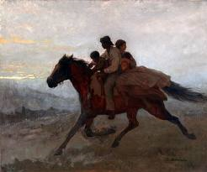

Monday: Write a simile and a metaphor about the image.

Simile: ________________________________________________________________________________________________________________

Metaphor: ________________________________________________________________________________________________________________

Tuesday: Write a Cinquain poem about the image.

_________________________

Noun

_____________________________________________________________________

Two Adjectives

______________________________________________________________________

3 Verbs

_______________________________________________________________________

Phrase

__________________________________________

Synonym for noun