**Symmetry and Space**

Symmetry: The property of being the same or corresponding on both sides of a central dividing line

1. C:\Users\Ashley\AppData\Local\Microsoft\Windows\Temporary Internet Files\Content.IE5\5LC7J36D\MC900234511[1].wmfExamples of symmetrical shapes: Draw the central dividing line of the following symmetrical shapes

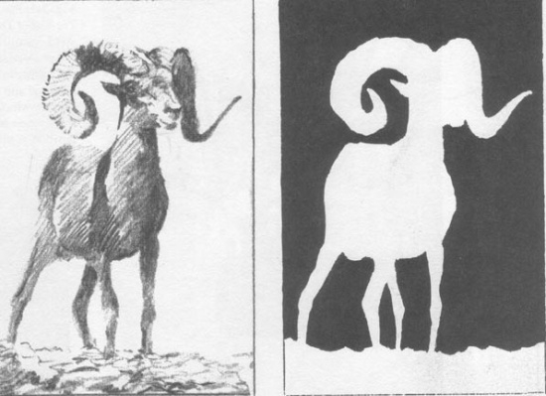Space: An element of art, space refers to distances or areas around, between or within components of a piece. Space can be *positive* or *negative*, *shallow* or *deep* and *two-dimensional* or *three-dimensional*. Sometimes space isn't actually within a piece, but the *illusion* of it is.

Contour line = out line Double contour line = Double out line

1. Positive/ negative practice : Simple shape
2. Get a full rectangle of construction paper and a half sheet of construction paper in different colors.
3. On the half sheet draw half of a simple symmetrical shape using contour lines; be sure the center of the design is along the right edge.
4. Cut the shape out
5. Glue the negative space of the half sheet to the whole sheet on the left side
6. Flip over the positive space along the central axis and glue to the right side along the axis line
7. Positive/ negative practice: Double line contour
8. Get a full rectangle of construction paper and a half sheet of construction paper in different colors.
9. On the half sheet draw half of a simple symmetrical shape using contour lines; be sure the center of the design is along the right edge.
10. Cut the double contour line out
11. Glue the negative space of the half sheet to the whole sheet on the left side
12. Flip over the positive space (the double contour line) along the central axis and glue to the right side along the axis line
13. Positive/negative practice: 4 quadrants
14. Get a full rectangle of construction paper and a half sheet of construction paper in different colors.
15. On the half sheet draw half of a simple symmetrical shape using contour lines; be sure the center of the design is along the right edge.
16. Fold the half sheet in half hamburger style and cut along the fold
17. Working with only the top half for now cut the double contour line out
18. Glue the negative space of the half sheet to the whole sheet on the left side top corner
19. Flip over the positive space along the central axis and glue to the right side along the axis line
20. Now cut the double line out of the bottom half
21. Glue the double contour line to the left side of the paper then the negative space gets flipped along the axis and glued to the right side bottom corner.

****Staple together and turn in all 3 practice pieces

**Designing Your Large Positive/ Negative Design**

Name____________________________

Directions: In the boxes below draw a complex symmetrical design. Your design must have a minimum of 8 elements in your design on each side