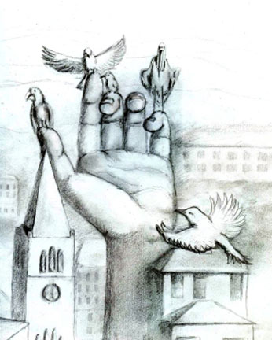
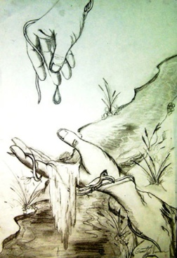
Handscapes
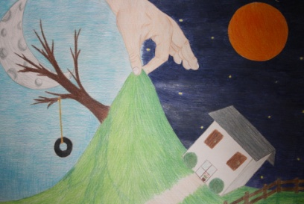

Objective: The student will learn to draw hands. Then the student will draw a hand interacting with a scene to create a surreal image.
Materials:
- Oil pastel
- 18x24 drawing paper
Directions:
- Draw 5 hands
- Choose the hand that is most successful. Think of how you can have the hand interacting with an environment. The hand can be holding, lifting, pushing, pulling…. Any object or part of a scene.
- Complete the brainstorming worksheet and turn it in.
- Draw or trace the hand lightly with pencil
- Add the scene also lightly in pencil.
- Use oil pastel to color in.
You will be graded on….
________/ 30 Hand incorporating with environment
________/ 20 Value/texture/ oil pastel technique
________/ 20 Realistic hand drawing
________/ 15 Creativity
________/ 10 Craftsmanship
________/ 5 Effort/ Production

Handscapes Brainstorming Name____________________________________
Fill each box with different idea in color.

