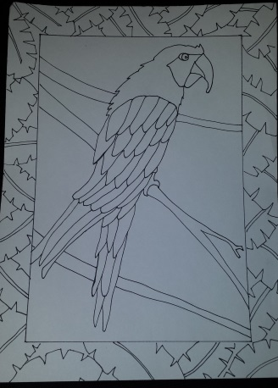
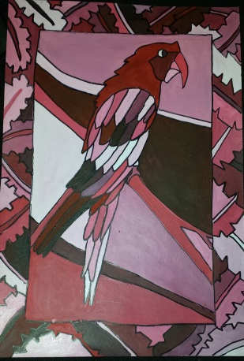
Art 1
Animals in COLOR
Objective: Create an interesting composition using an animal and its habitat. This composition will be repeated and painted using various color schemes.
Requirements:
- Interesting composition
- Animal in habitat
- Background must be divided into a minimum of 4 sections
- Must have a border filled with pattern inspired by animal or habitat
Steps:
- Using the packets pick and draw 5 different animals include their habitat
- Pick your best animal and redraw it on the drawing paper- include the habitat.
- Draw a border filled with a pattern inspired by animal or habitat
- Make sure the habitat divides the background into at least 4 sections
- Trace it onto another sheet of paper
- Create monochromatic value scales using paint
- Number your drawing 1-10 signifying the various colors you will use
- Paint all number 5’s
- Mix and paint all tints according to the numbers
- Mix and paint all shades according to the numbers

