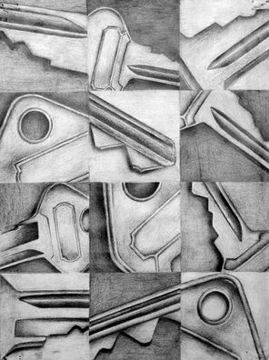
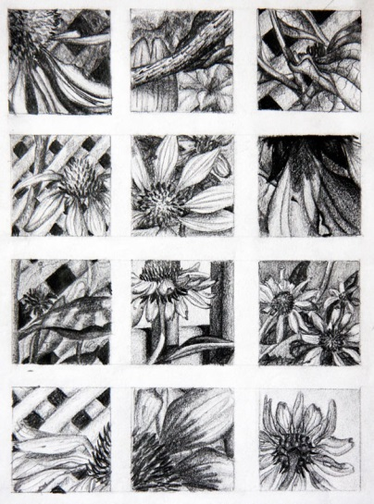
Art 2

9 Perspectives 1 Object

Objective: Investigate and illustrate 1 object from using 9 different vantage points. Consider the visual movement and balance of the composition as a whole.
Materials:
- Paper
- Pencil
- Choice of pencil, pen and ink, or color pencil/marker
Steps:
- Pick 1 object which has multiple vantage points and areas of interest.
- Investigate the object from a series of sides, angles, and distances.
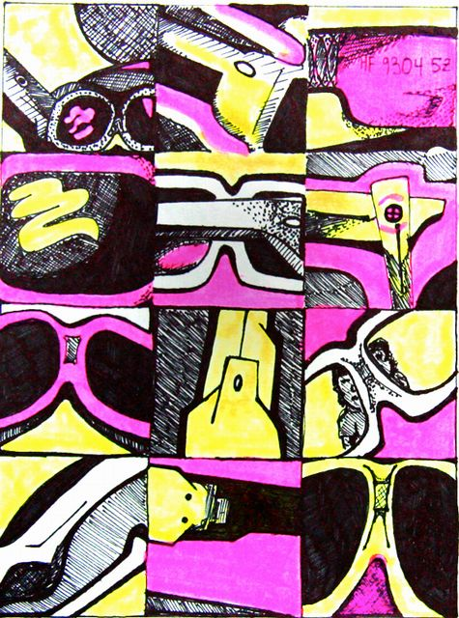
- Choose to either make a grid with nine 3”x3” squares or work on squares individually then the squares will be glue down onto one composition upon completion.
- Draw your object from a different sides, angles, or distances in each of the 9 squares lightly. Vary your line weight (don’t flatten your piece by enclosing the object in a heavy outline)
- Add value in pencil, pen, or color pushing the darks and lights to establish high contrast. **Hint No more than 5% of your drawing should be white (reserve the white for the brightest highlights only)
- Complete your composition making sure there is visual movement from one square to the next, and there is unity throughout all elements of art.
.

